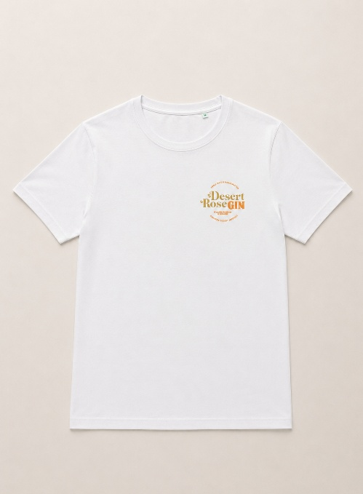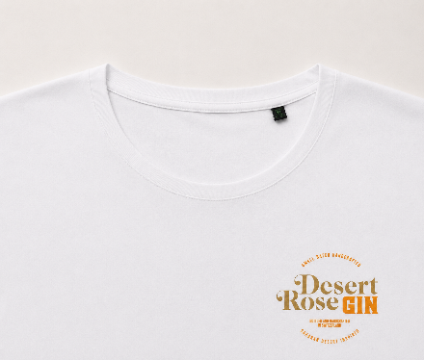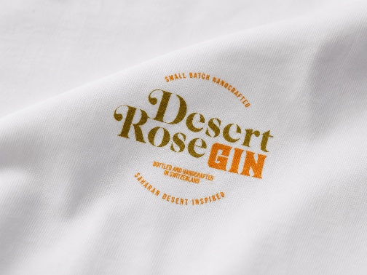
Men's T-Shirt Desert Rose Gin – Organic Cotton
Essential, comfortable and versatile, the Desert Rose Gin Men's T-Shirt is the ideal garment for those who want to combine style, quality and sustainability in a single product.
Made from 100% organic cotton, it feels soft and natural against the skin, ensuring breathability and comfort throughout the day.
The regular masculine fit ensures a comfortable and contemporary line, suitable for any occasion. The classic reinforced crew neck and the refined finishes complete a garment designed to last over time and maintain an impeccable appearance even after numerous washes.
On the chest there is the Desert Rose Gin logo, discreet but distinctive, which gives character to the t-shirt while maintaining a clean and elegant style.
Features
- 100% organic cotton
- Men's fit regular
- Soft and durable crew neck
- Lightweight, breathable and comfortable fabric
- Desert Rose Gin logo on the chest
- Color: White
- Essential and versatile design
Available sizes
Available in sizes:
- M
- L
- XL
- 2XL
Garment care
- Wash at maximum 30°C
- Wash and iron inside out
- Do not use bleach
- Do not tumble dry
A t-shirt that combines comfort, sustainability and timeless style, perfect for experiencing and representing the Desert Rose Gin universe on any occasion.

